Perla Garcia Cavazos
Module 2.3 — Data Models Assignment

[ERD Screenshot]

[NoSQL JSON Screenshot]

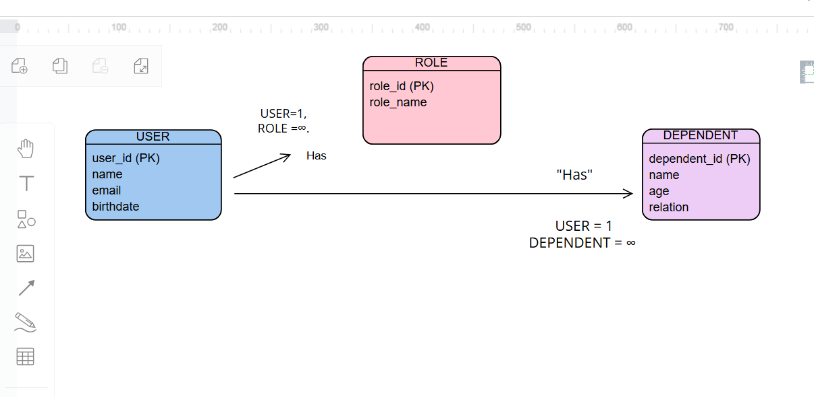

{
"user_id": "U001",
"name": "Perla Garcia Cavazos",
"birthdate": "1990-05-12",
"roles": [
{ "role_id": "R001", "role_name": "Admin" },
{ "role_id": "R002", "role_name": "Editor" }
],
"dependents": [
{ "dependent_id": "D001", "name": "Child One", "age": 7, "relation": "Son" },
{ "dependent_id": "D002", "name": "Child Two", "age": 4, "relation": "Daughter" }
]
}

